

NAME : KAVISHA JAYAMOHAN

LOGIN ID : [kavisha@oasis-portal.com](mailto:kavisha@oasis-portal.com)

COURSE TITLE : TOURISM & HOSPITALITY

SUBJECT CODE : BHM04

TABLE OF CONTENTS

|  |  |  |
| --- | --- | --- |
| NO | DETAILS | PAGE |
| 1 | EXECUTIVE SUMMARY | 3 |
| 2 | INTRODUCTION | 4 |
| 3 | ASSIGNMENT QUESTION |  |
|  | PART 1 | 5-10 |
|  | PART 2 | 11-26 |
|  | PART 3 | 27-33 |
|  | PART 4 | 34 |
| 4 | CONCLUSION | 35 |
| 5 | REFERENCES | 36 |
| 6 | APPENDIX | 37 |



***INTRODUCTION***

As known to everyone tourism and hospitality has been present ever since the beginning of the human race. But it is to be seen that how it is evolved since the time when hospitality was just a manners way to express an emotion towards family and friends when they visit ones place and make them feel comfortable and at home all the time and at times even going the extra mile to make them feel comfortable and happy. To a time when everything changed and hospitality was no more just an expression but become something which was much more professional, much more personalised, catering to every guest personal needs and making them feel comfortable and this came to be known as the Hospitality Industry. As time progressed, slowly but steadily the Hospitality Industry has been able to make its presence felt in the Service Sector, and today the Hospitality Industry is one of the major contributors in the Service Sector. So, basically we are going to talk about the history of the commercial hospitality from the antiquity to the 19th century and how in evolved around this time.

***EXECUTIVE SUMMARY***

In this module, I will cover the topic of Tourism and Hospitality and will show the concept of Tourism and Hospitality. In the first part of question, we can see the introduction of Tourism and Hospitality and its importance and roles of tourismand hospitality. Besides that, i would like to share some information about advantage and disadvantage of tourism and hospitality. In second part of question, I will describe about the types of tourism and hospitality. Furthermore, I will describe different type of hotels and its importance. While, in third part of question i would talk about a lodging accommodation and hotel accommodation. Last but not least, i will explain about the significant of entertainment in this industry. Entertainment is a huge thing there are sports and gaming, cruise, night club, bars and etc. This tourism and hospitality give me too much information and a lot of knowledge.

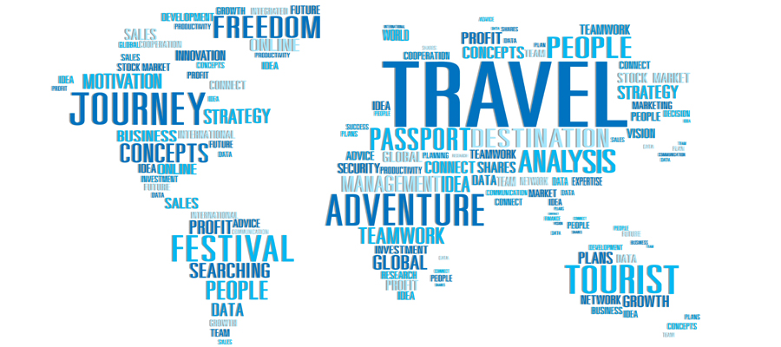

***Question 1***

1.Define the Tourism and Hospitality.

TOURISM

Tourism is a collection of activities, services and industries which deliver a travel experience comprising transportation, accommodation, eating and drinking establishments, retail shops, entertainment business and other hospitality services provided for individuals or groups traveling away from home.

The sum of the phenomena and relationships arising from the interaction of tourists, business suppliers, host governments and communities in the process of attracting and hosting these tourists and other visitors

Tourism is not only concerned with the movement of people but also includes various other service providing agencies. The movement of people is temporary in nature as it goes up to a maximum of 1 year, which gives a boost to the economy, creating job opportunities.

HOSPITALITY

Hospitality is the relationship between guest and host, or the act or practice of being hospitable. Specifically, this includes the reception and entertainment of guests, visitors, or strangers, resorts, membership clubs, conventions, attraction, special events, and other services for travellers and tourists. Hospitality can also mean generously providing care and kindness to whoever is in need.

The hospitality industry is a several billion dollar industry that mostly depends on the availability of leisure time and disposable income. A hospitality unit such as a restaurant, hotel, or even an amusement park consists of multiple groups such as facility maintenance, direct operations (servers, housekeepers, porters, kitchen workers, bartenders, etc), management, marketing, and human resources.

DEFINITION OF TOURISM & HOSPITALITY

The industry of providing customer service to travelers or strangers.Hospitality professionals generally work in administrative or management positions in a service based environment, and they are responsible for overseeing the operations and success of an establishment, such as a hotel or restaurant. The hospitality and tourism industry is diverse, and includes many locations including RV parks, food establishments, recreational facilities, campgrounds, boarding houses and youth hostels. While the overall goal of a hospitality professional is to ensure that guests and customers have pleasurable experiences, they can also be responsible for operations, such as hiring and training new staff, supervising office and financial administration, housekeeping, maintenance, and security staff, and marketing.

Hospitality professional also distribute funds, set room rates, and ensure that the service standards of the business are met. General duties for hospitality professionals very depending on the size of the business and the amount of staff available. In larger operations, there is usually a hierarchy of general managers, assistant managers and supervisors who work to perform operational tasks relating to their areas of expertise. In a smaller business , the hospitality professional performs these tasks directly.

Sometimes hospitality professional positions are specialized. For example, some focus on managing the front office, while others can be responsible for convention services or financial administration. If a hospitality professional is employed in a specialized position, he or she must have excellent communication skills and the ability to work well alongside coworkers in other areas of the business.

Employers prefer applicants with a bachelor’s degree in business or hotel or hospitality management, but a liberal arts degree along with hospitality experience may also be acceptable. Smaller establishments may accept applicants with a certificate or associate’s degree in hotel, hospitality or restaurant management.

HOSPITALITY INDUSTRY

Most people think that hotels alone belong to the hospitality industry, but hotels are only one sector of this industry. Many forms of transportation, lodging, restaurants, and cuisine that caters to tourists are also part of this business. For example, this niche includes airlines, cruise ships and even fancier trains. Restaurant, general tourism and event planning also belong in this category. Some of these business partially belong to the hospitality industry. For example,a fast food restaurant would be considered convenient. A restaurant that provided fancy food with amazing service would be providing a hospitality service.

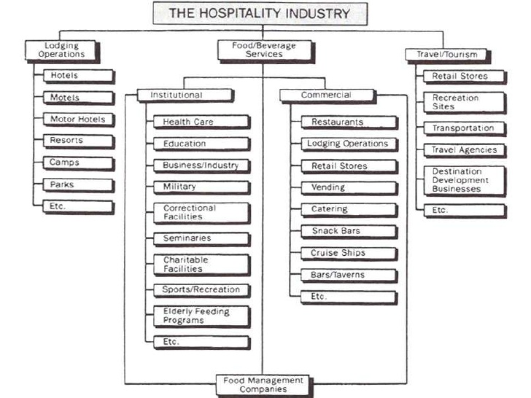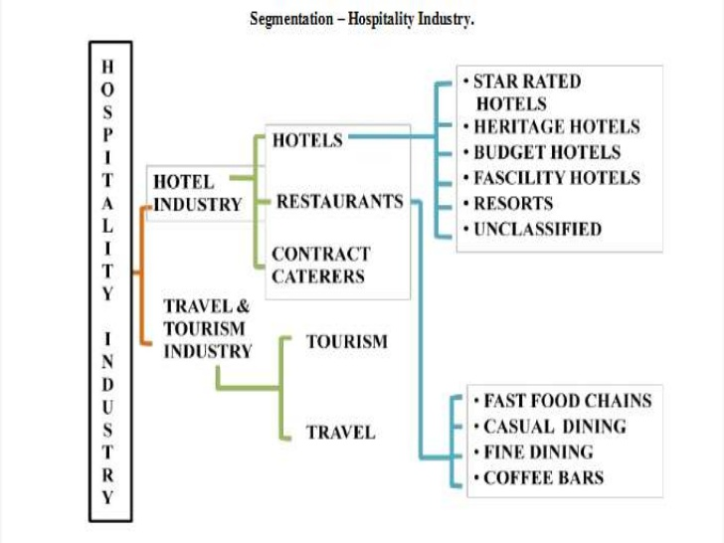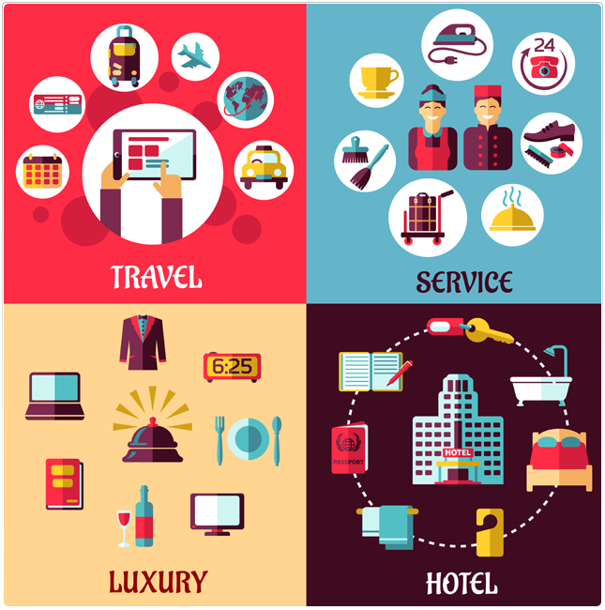

**QUESTION 2**

1. Define tourism

Tourism is travelling for recreational, leisure, family or business purpose, usually for a ltd duration. Tourism is mainly associated with trans national level, bu may also refer to travel to another location within the same country. It is important to preserve and protect our natural resources, culture and traditions and for this tourism is vital factor. Tourism is not only concerned with the movement of people but also includes various other service providing agencies. The movement of people is temporary in nature as it goes up to a maximum one year, but the impact on allied service industry is long lasting, which gives a boost to the economy, creating job oppurtunities.

IMPORTANCE OF TOURISM

Tourism is vital for many countries, due to the income generated by consumption of godds and services by tourists, the taxes levied on businesses in the tourism industry, and the opportunity for employment and economic advancement by working in the industry. For these reasons NGOs and government agencies may sometimes promote a specific region as a tourist destinations, and support the development of a tourism industy in that area.

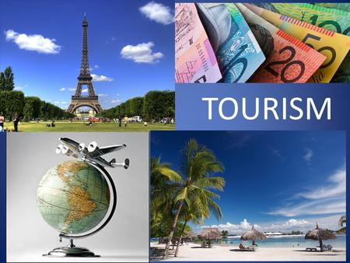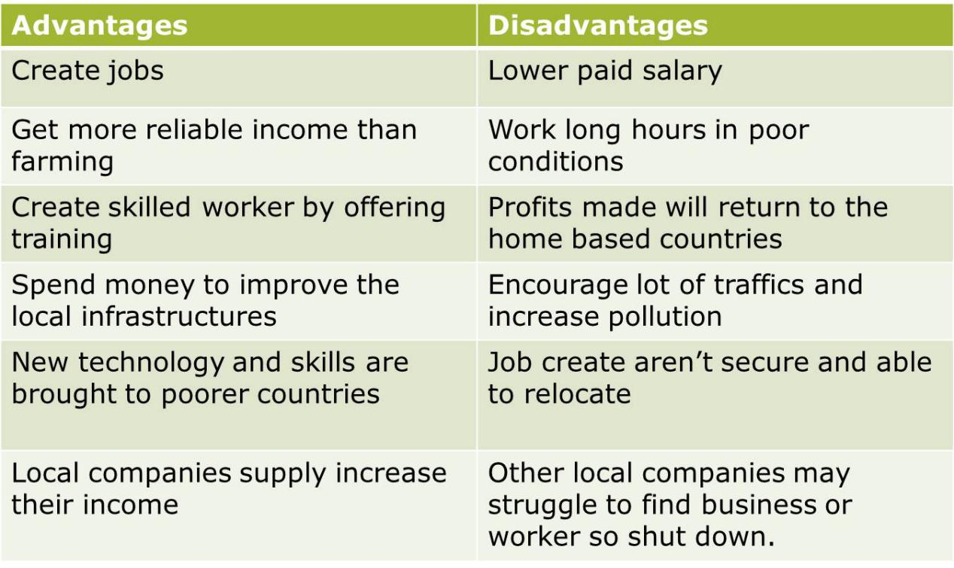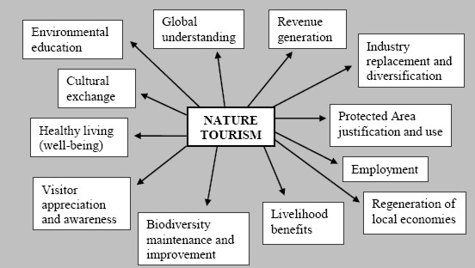

***What are the tourism product ?***

≈ The tourism product consists of the 6A’s

≥ Access (transportation)

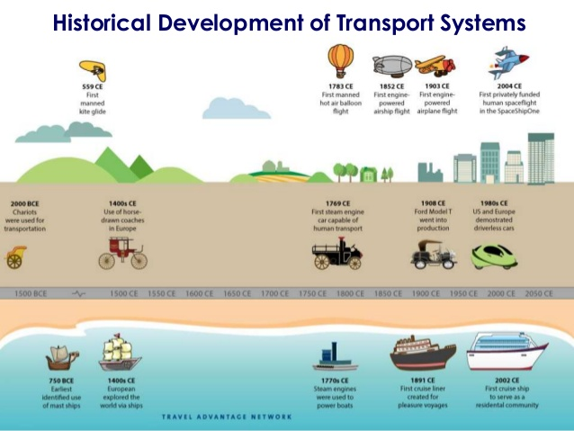

≥ Accommodation (places to stay overnight)

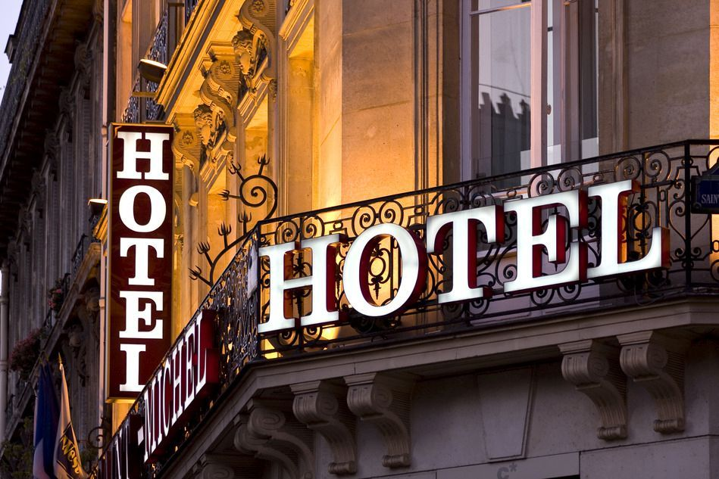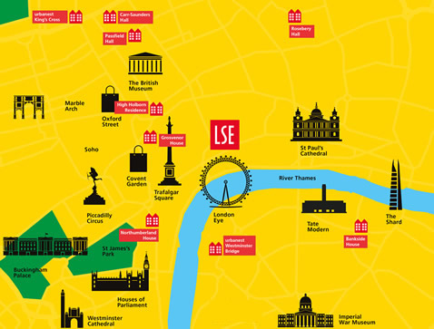

≥ Attraction (natural or man made)

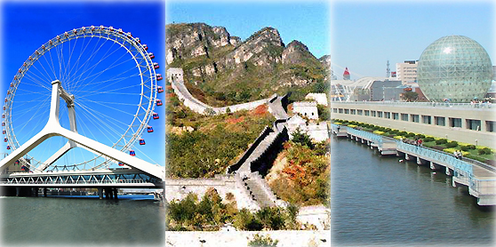

≥ Activities (festival and event)

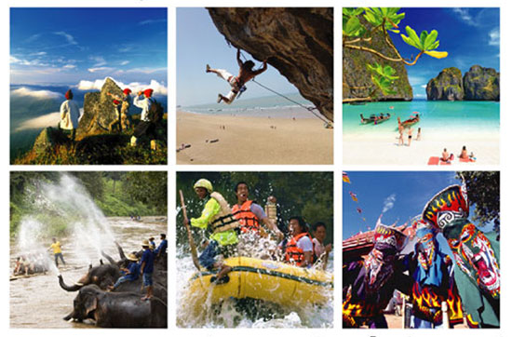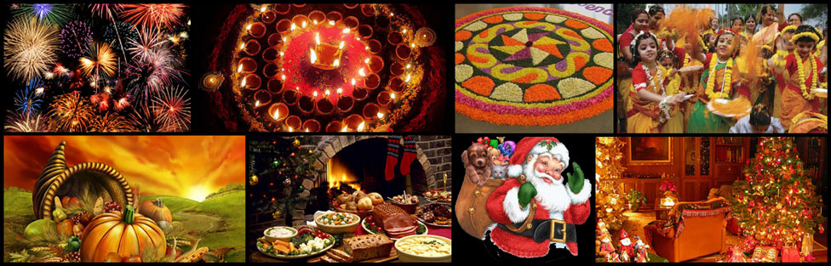

≥ Amenties (essential facilities)

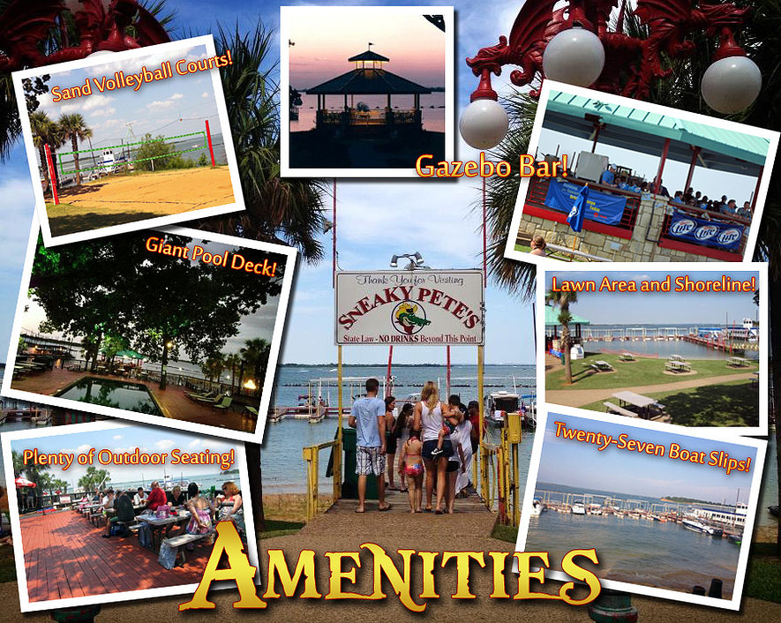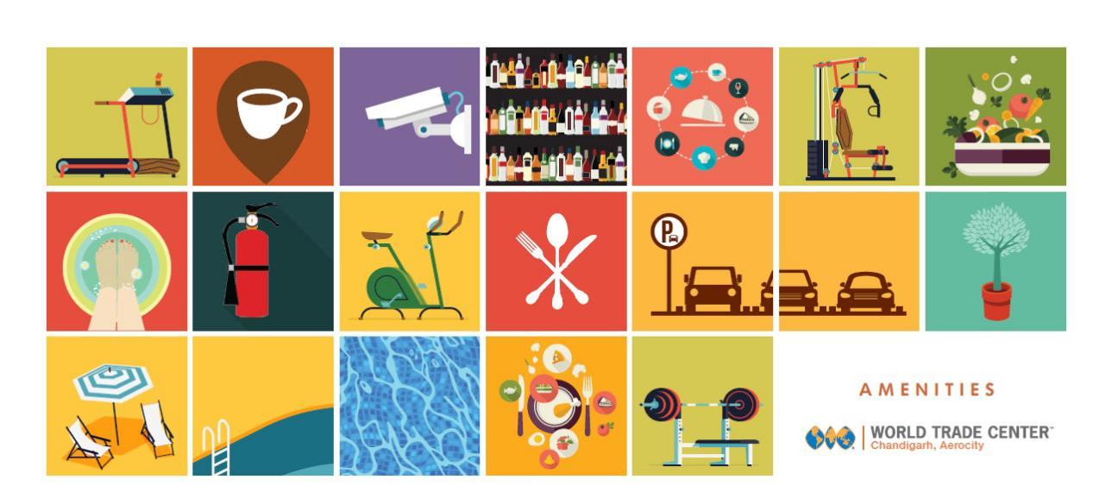

≥ Ancillary (extra services)

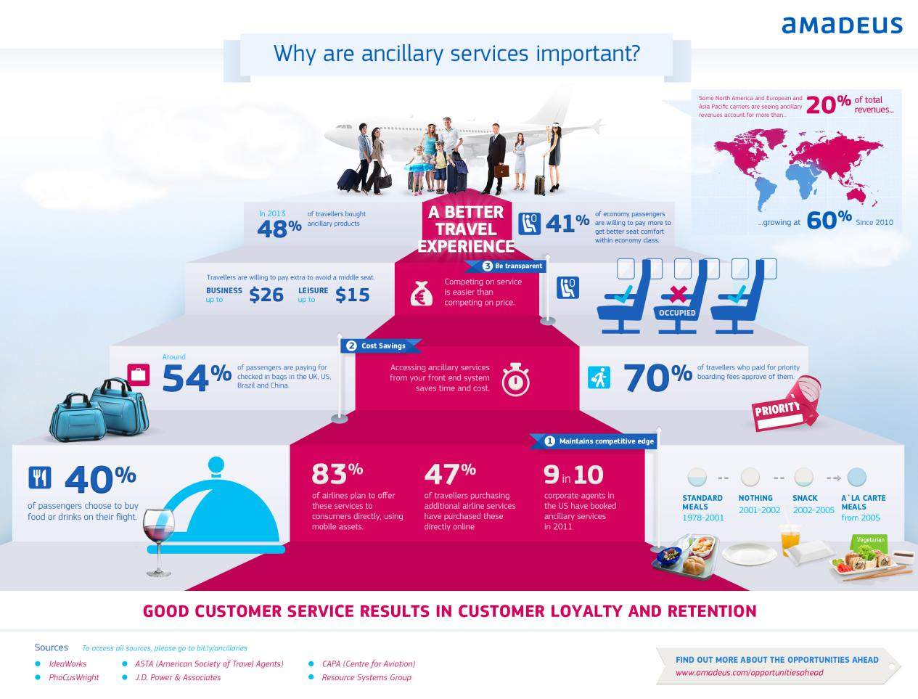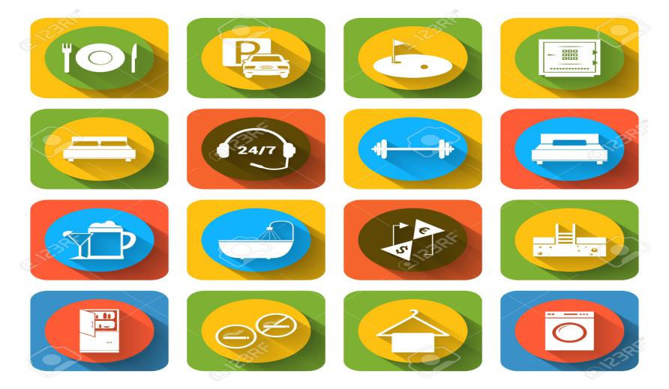

***What is Hospitality ?***

When we speak of hospitality we are always addressing issue of inclusion and exlusion.Each of us make choices about will and who will not be included in our lives.Hospitality has inescapable moral dimension to it. All of our talk about hospitable opennes doesn’t mean anyting as longas some people continue to be tossed aside.But calling hospitality a moral issue does not tell us the whole truth about hospitality either.A moral issue can become bogged down in legalisms,and hospitality is no legalistic ethical issue.it is instead a spiritual practice,a way of becoming more human,a way of understanding yourself.Hospitality is both the answer to modern alienation and injustice and a path to a deeper spirituality.

≥ fields within service industry

≥ lodging,event planning,theme parks,tranportation,cruise line

≥ hospitality units such as restaurants,hotels,amusement park



What is a tourists?

1. Leisure (holiday)



1. Business



1. Pilgrimage

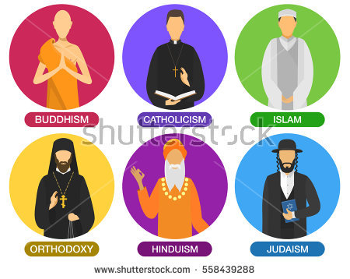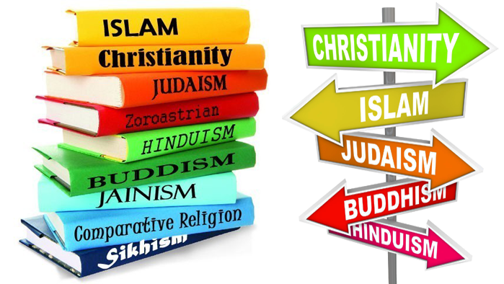

4.Recreation



1. Adventure

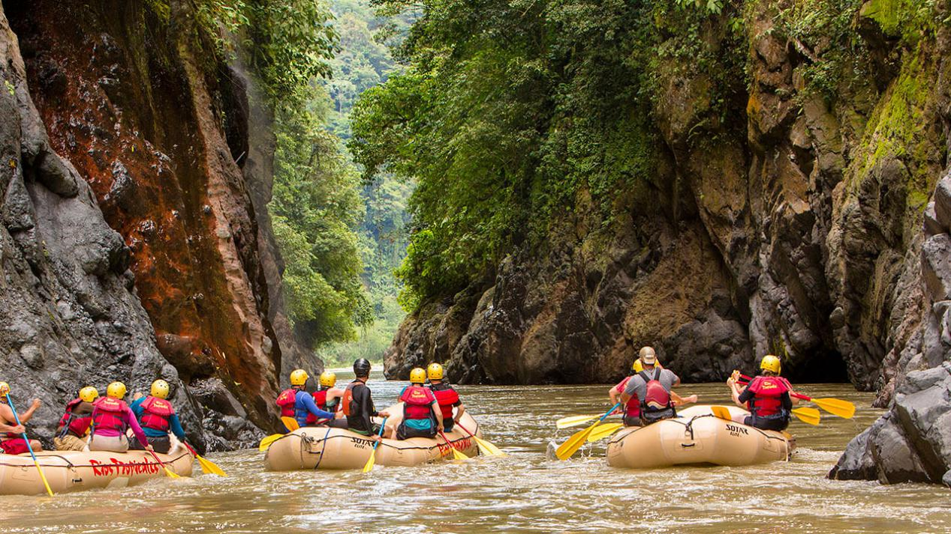

1. Health



1. Education



1. VFR

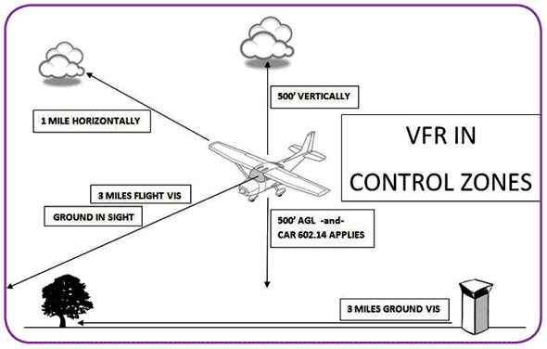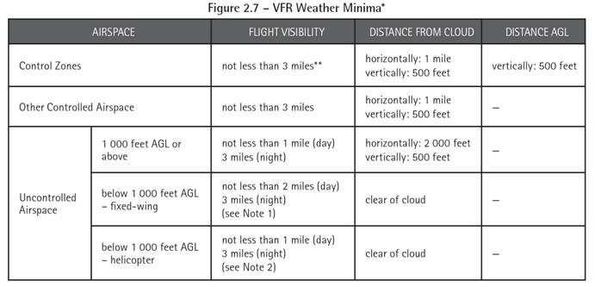

***QUESTION 3***

1. Describe the lodging accommodation and types of Hotel accommodation.

LODGING ACCOMMODATION

Lodging or a holiday accommodation is type of residental accommodation. People who travel and stay away from house for more than a day need lodging for sleep, rest, food, safety, shelter from cold temperatures or rain, storage of luggage and access to common household function

Lodging may be self-catering, in which case no food provided, but cooking facilities are available.

Lodging is done in a hotel, motel, hostel or hostal, a private home(commercial I.e.a bed and breakfast, a guest house, a vacation rental, or non-commercially, with members of hospitality services or in the home of friends), in a tent,camper(often on a campsite).

TYPES OF HOTEL ACCOMMODATION

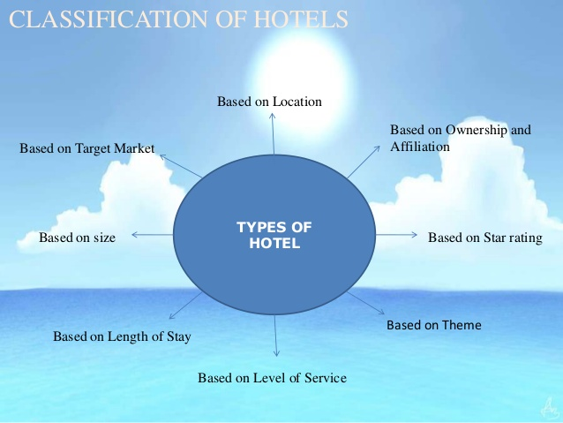

Examples:

1. Villa- Originated in Roman times, a villa is often describe as a luxurious country residence.

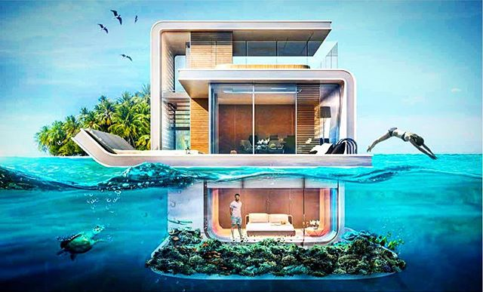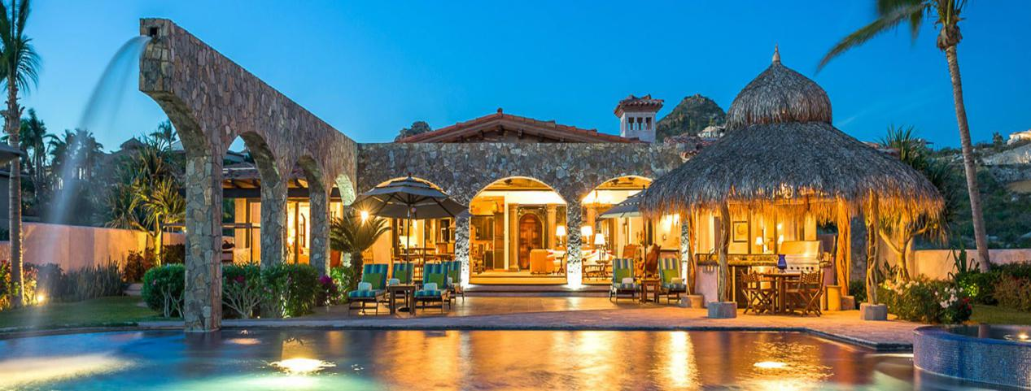

b)Boutique Hotel- Often furnished in a themed, individual style, boutique hotels are intimate in size and focus on providing guests with high quality, personalized experiences.

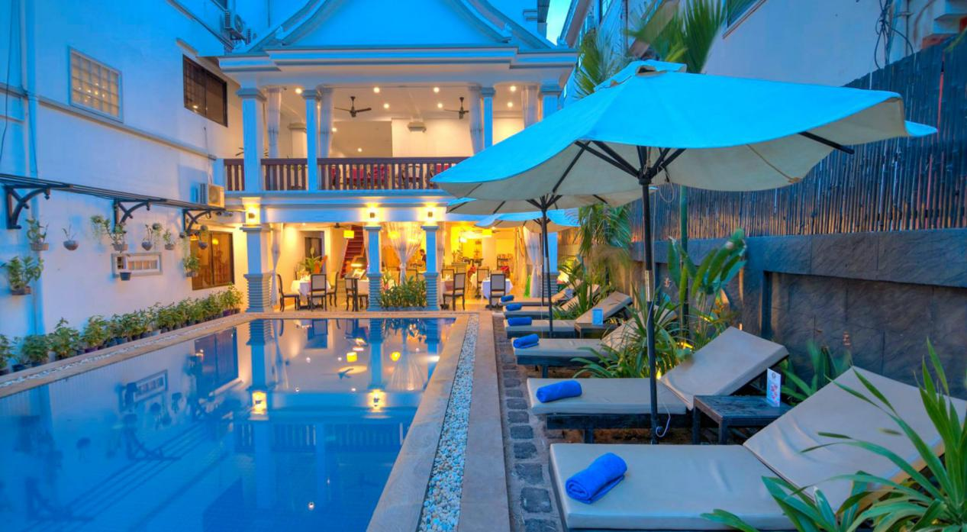

c) Treehouse - Usually designed for recreational purposes, a treehouse, or tree hpouse, is a structure built or placed among the branches of a tree.

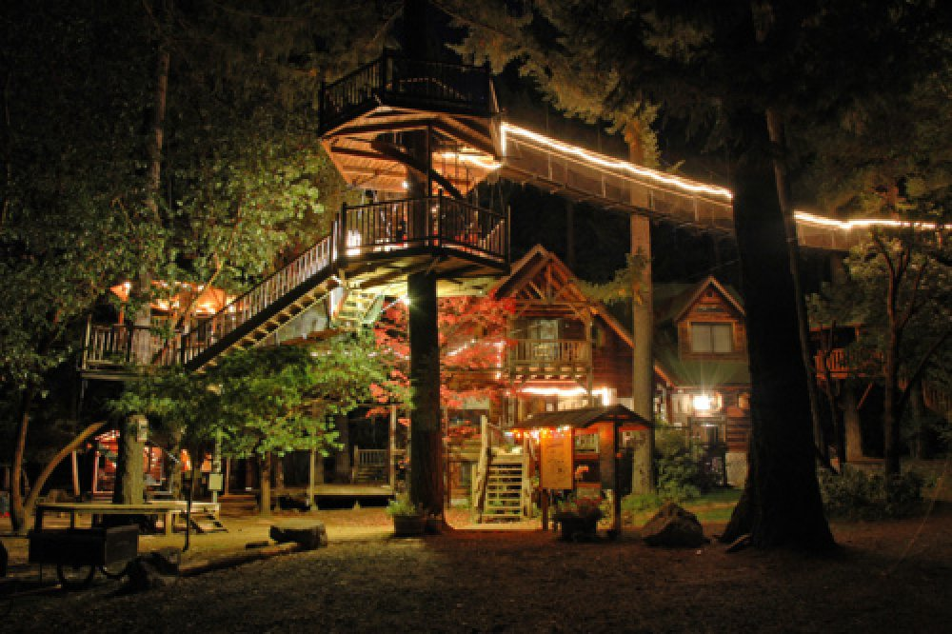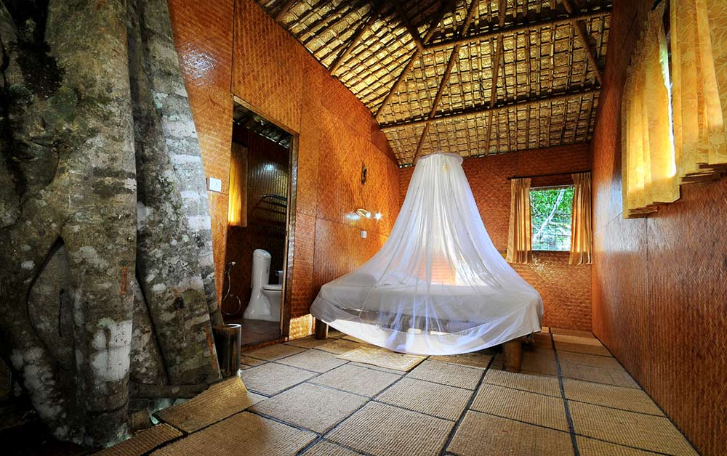

d) Riad - A traditional Morrocan house built around a central courtyard, often converted into an intimate hotel or guesthouse.

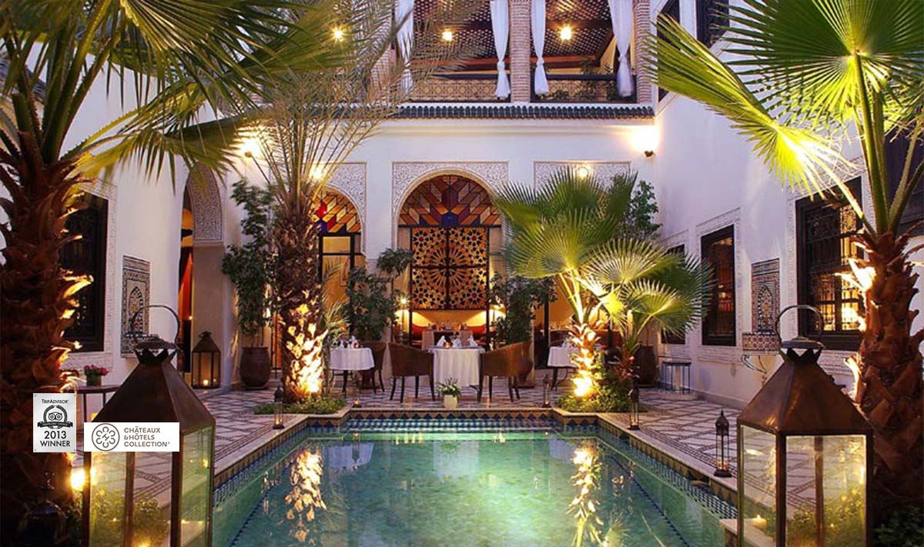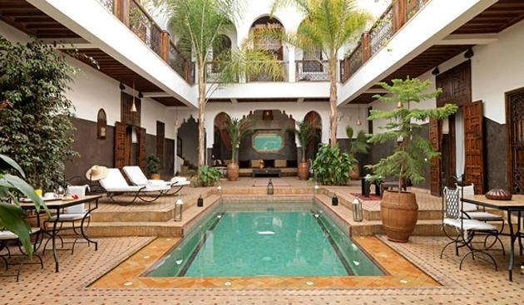

e) Igloo - A typical Eskimo house, an igloo is a dome-shaped snow structure meant to provide temporary or permenant shelter in cold climates.

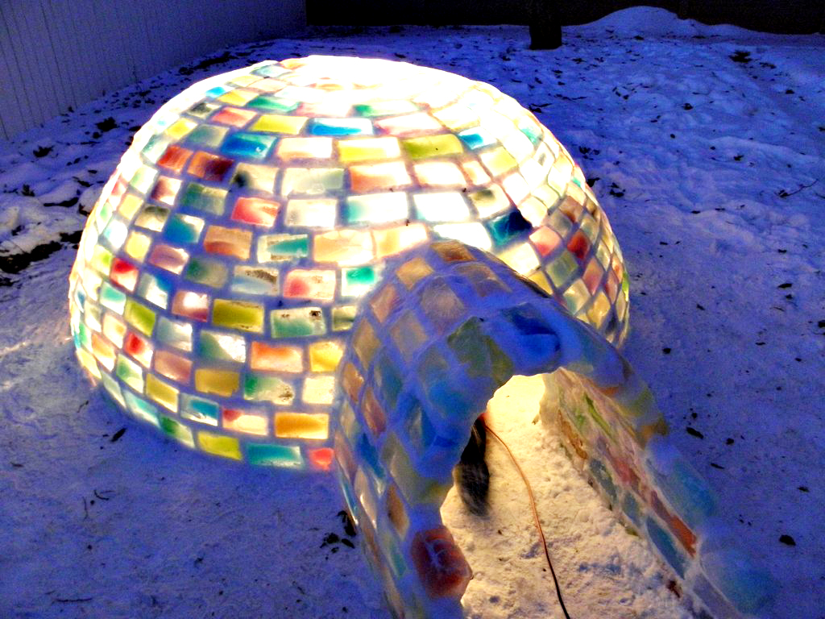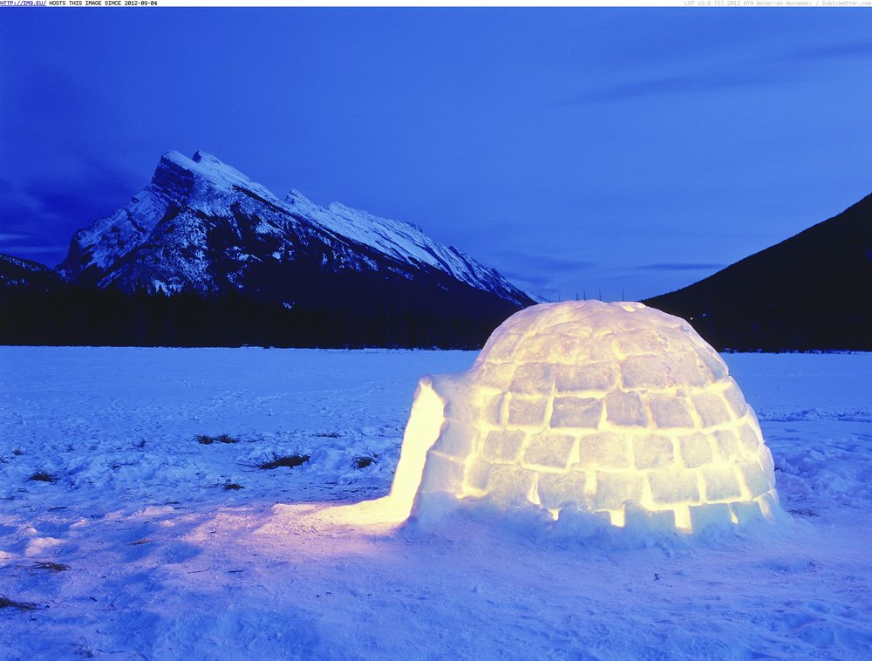

QUESTION 4

1. Explain the significant of Entertainment in this industry.

The term entertainment includes any activity that provides a diversion, amusement or is used as a method of occupying time

- watching TV

- attending live shows,such as concert

- going to the movies

- listening to music

- reading books or magazines

- playing video games

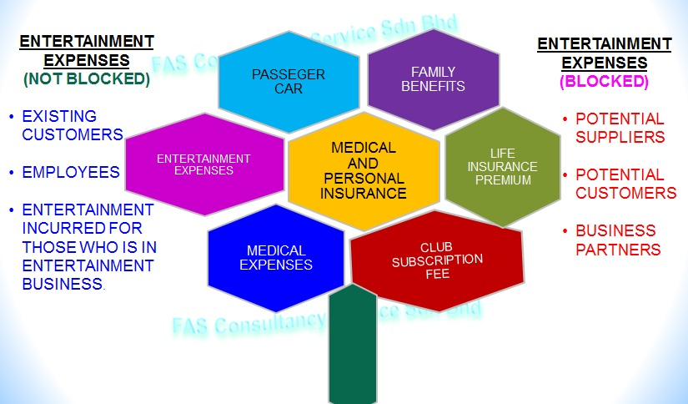

CONCLUSION

In this assignment, I learned a lot of about Tourism and Hospitality Industry knowledge and the overall operation of its importance. The first question the definition are based on current trends and future trends on nature of a particular modern organization. Tourism and Hospitality information to individuals and group both inside and outside the organization in order to help them, access them. Therefore, the second question all know that time when everything change and hospitality was no more just an expression but became something which was much more professional, much more personalized, catering to every guests personal needs and making them feel comfortable and this came to be known as the hospitality industry.The third question is about tourism as numerous tangible and intangible elements. Measure tangible elements include transportation, accommodation and other components of the hospitality industry.So basically, we are going to talk about the history of the commercial hospitality industry from the antiquity to the 20th century and how it evolved around this time.



REFERENCES

1. <https://www.slideshare.net/Brendan>Carreiro/clipboards/my clips?rftp=top-clipboards
2. https:www.slideshare.net/SBrooker/tourism-ppt-7748923
3. [https://www.tourism.com/definition/explanation](https://www.accountingcoach.com/accounting-equation/explanation)
4. [https://www.hospitality explanation.com/importance_explanations.htm](https://www.accountingexplanation.com/final_accounts_explanations.htm)
5. [https://www.travel and tourism.com/articles/201`7/](https://www.accountingtools.com/articles/201`7/bank-reconciliation)

6.https://www.tourism and hospitality/images.com

APPENDIX

